French Data Protection Act Compliance for Log360
Tagline: Meet France's data protection obligations with log monitoring from Log360.

Overview
The French Data Protection Act (Loi Informatique et Libertés) Compliance extension for Log360 helps French data controllers and processors meet the security monitoring, access audit, and breach notification requirements under French data protection law, as aligned with the GDPR framework.
Log360 collects and analyzes logs from databases, cloud environments, applications, and identity systems, providing visibility into personal data access and processing activities. Security and DPO teams can detect unauthorized access to personal data, investigate incidents, and generate CNIL-ready audit documentation.

Key Features
- Generate predefined compliance reports covering personal data access events, authentication logs, and system security activities relevant to the French Data Protection Act.
- Monitor access to personal data repositories across cloud and on-premises environments, detecting unauthorized queries and bulk data exports in real time.
- Configure alerts for breach indicators such as unauthorized access to sensitive databases, unusual data movements, and audit log tampering.
- Export compliance evidence in PDF and CSV formats for CNIL investigations, DPO records, and internal governance reviews.
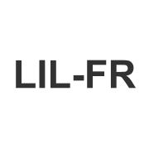
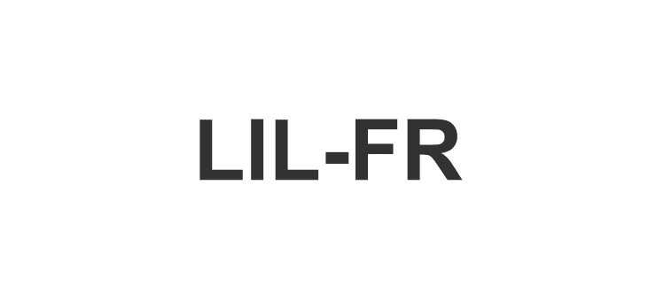

Screenshots
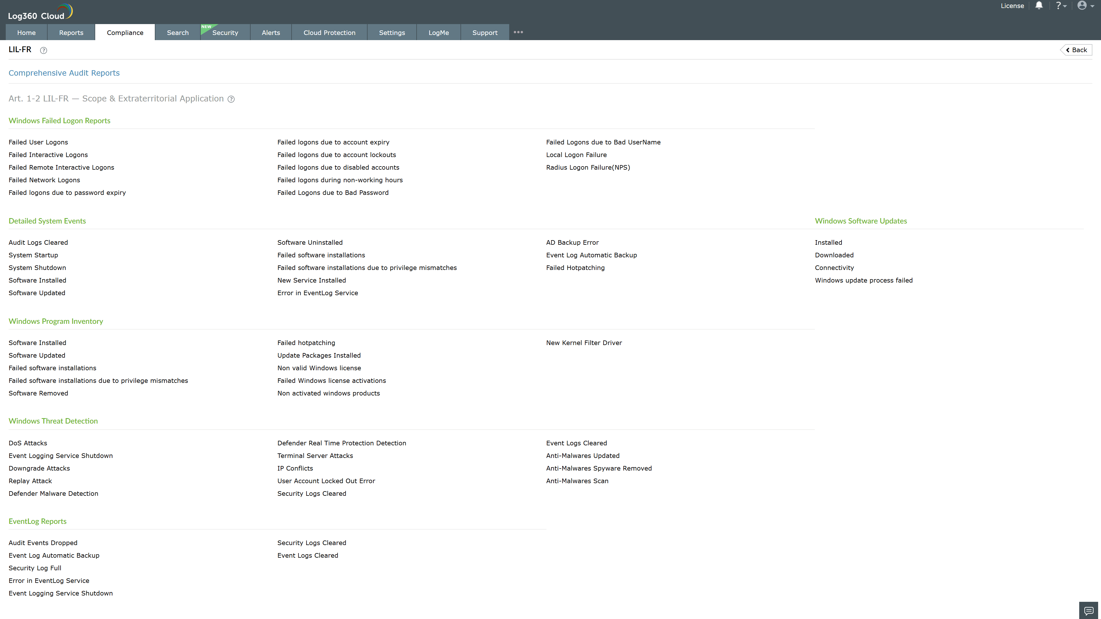
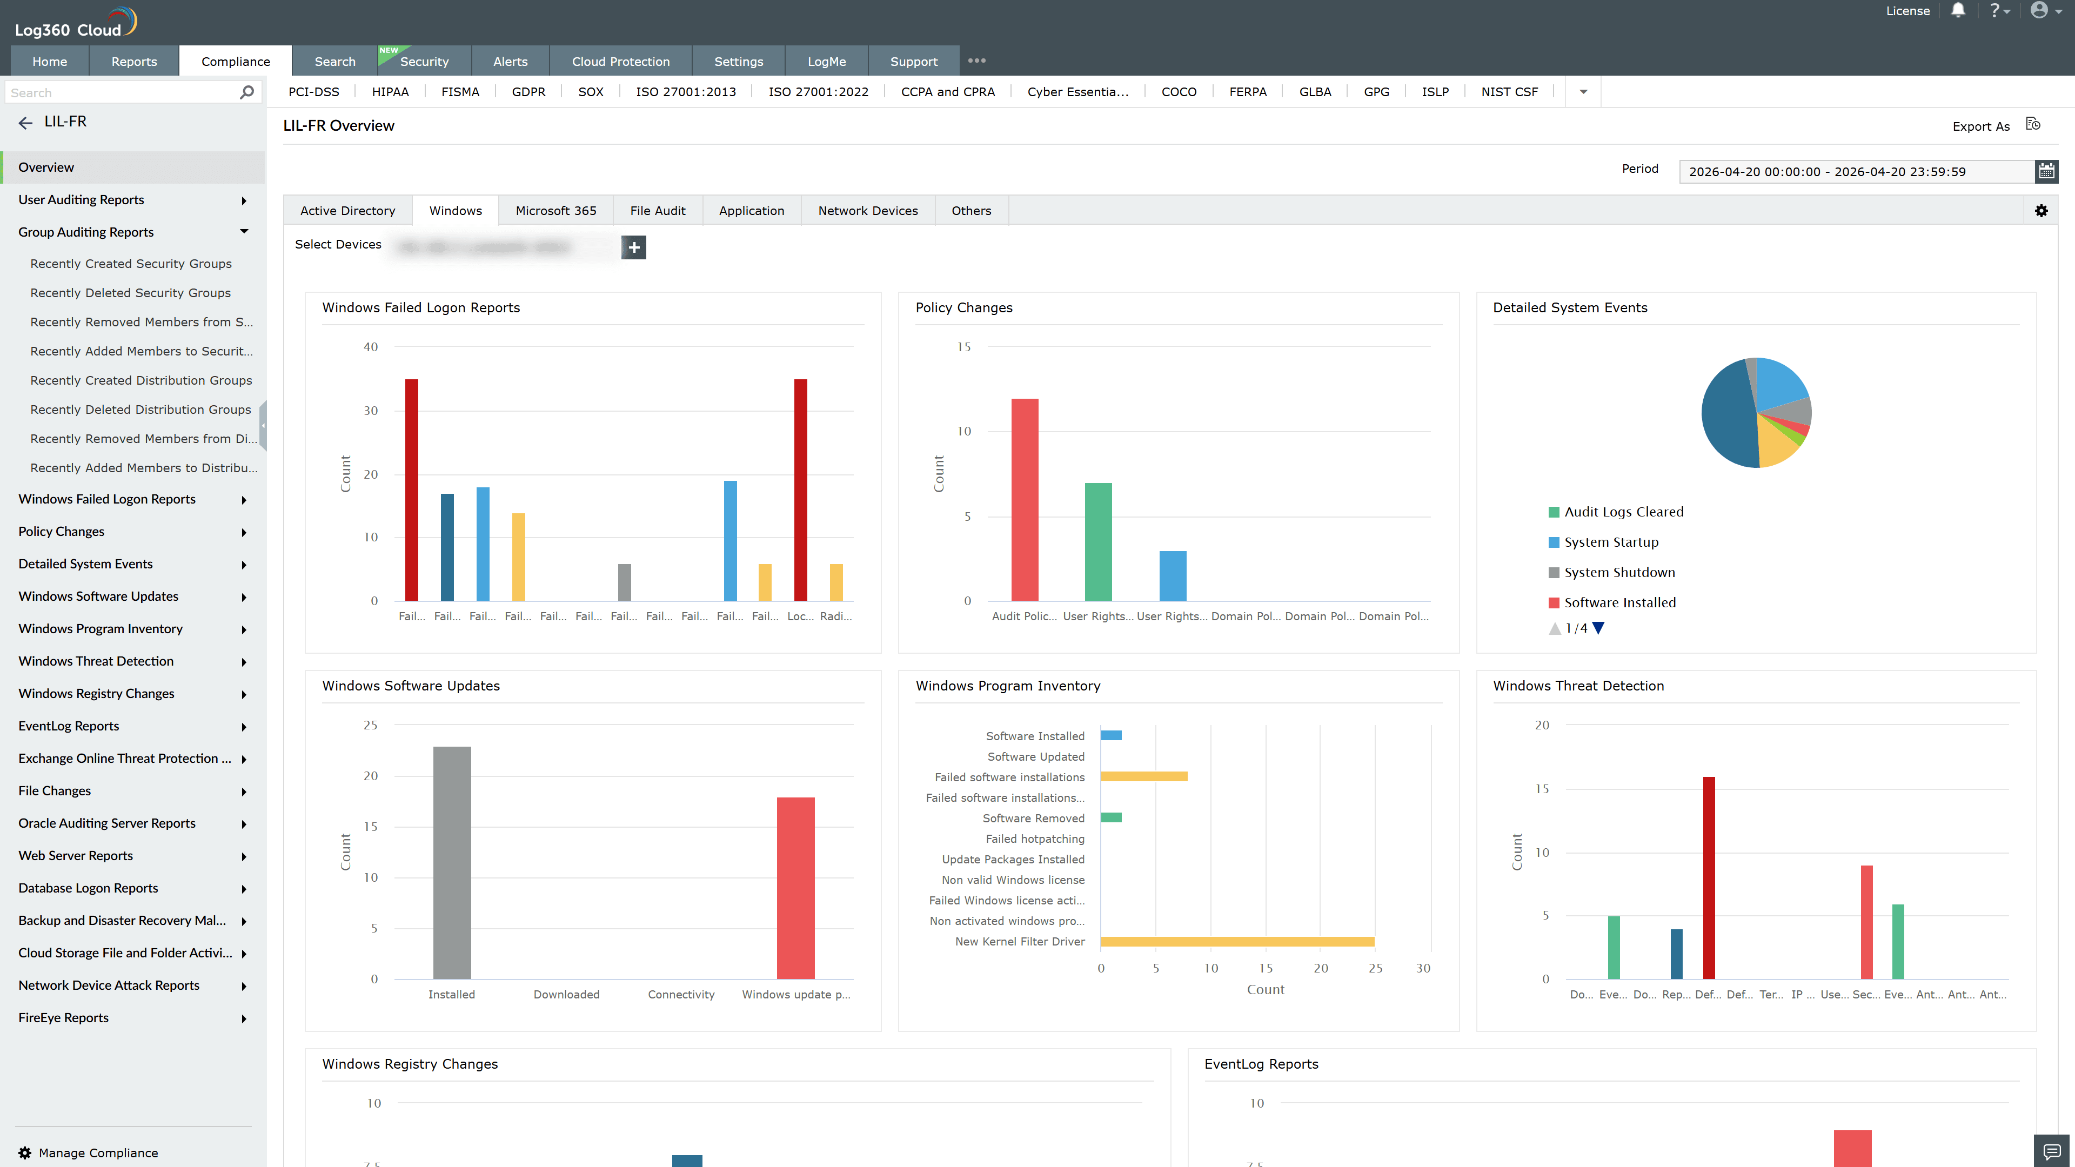
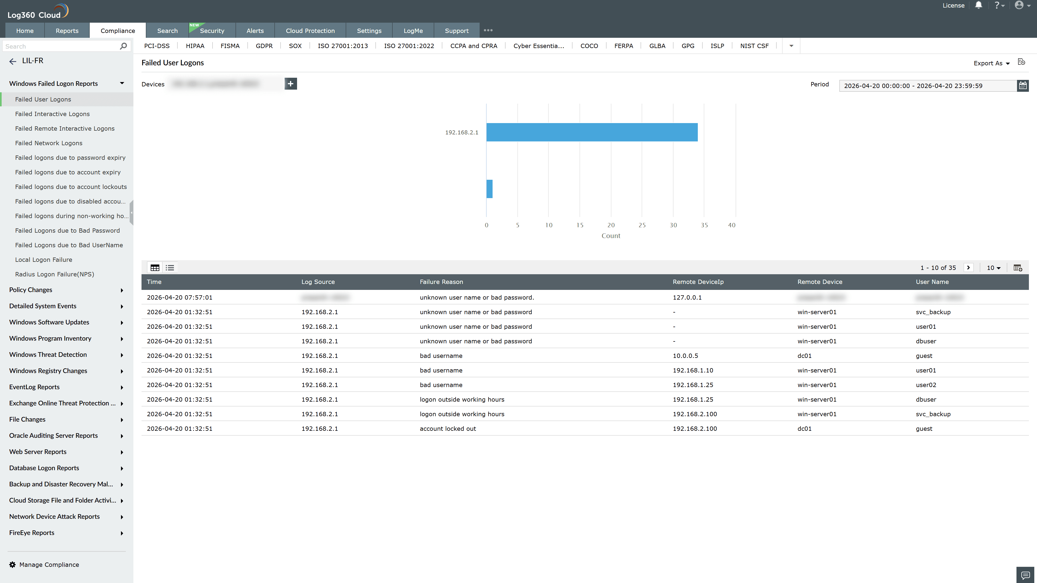
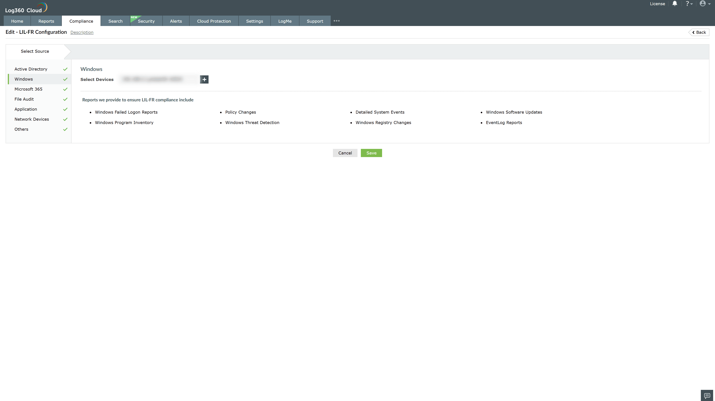

Valid Submission : Yes
Supported Editions : Free, Basic, Standard, Professional, MSSP
Help Document : https://www.manageengine.com/log-management/help/integrations/compliance-extensions.html
Help Video : Not provided
Tags : Log360, Compliance, Privacy monitoring, Data privacy, Regulatory compliance
Supported DCs : US, IN, JP, CA, AU, UK and EU
Privacy Policy:
Terms of Service:
Release Notes:
Predefined reports for the French Data Protection Act (Loi Informatique et Libertés) Compliance

